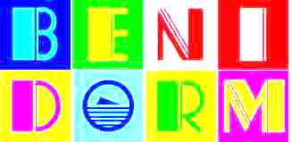
Useful Benidorm
Telephone Numbers
Tourist Info 965 960 095
Police 965 855 308
Clinica Rincon 966 830 849
Buses 902 422 242
Taxi 965 861 818
British Consul 965 216 190
Airport 966 919 400

